FARADAY FUTURE

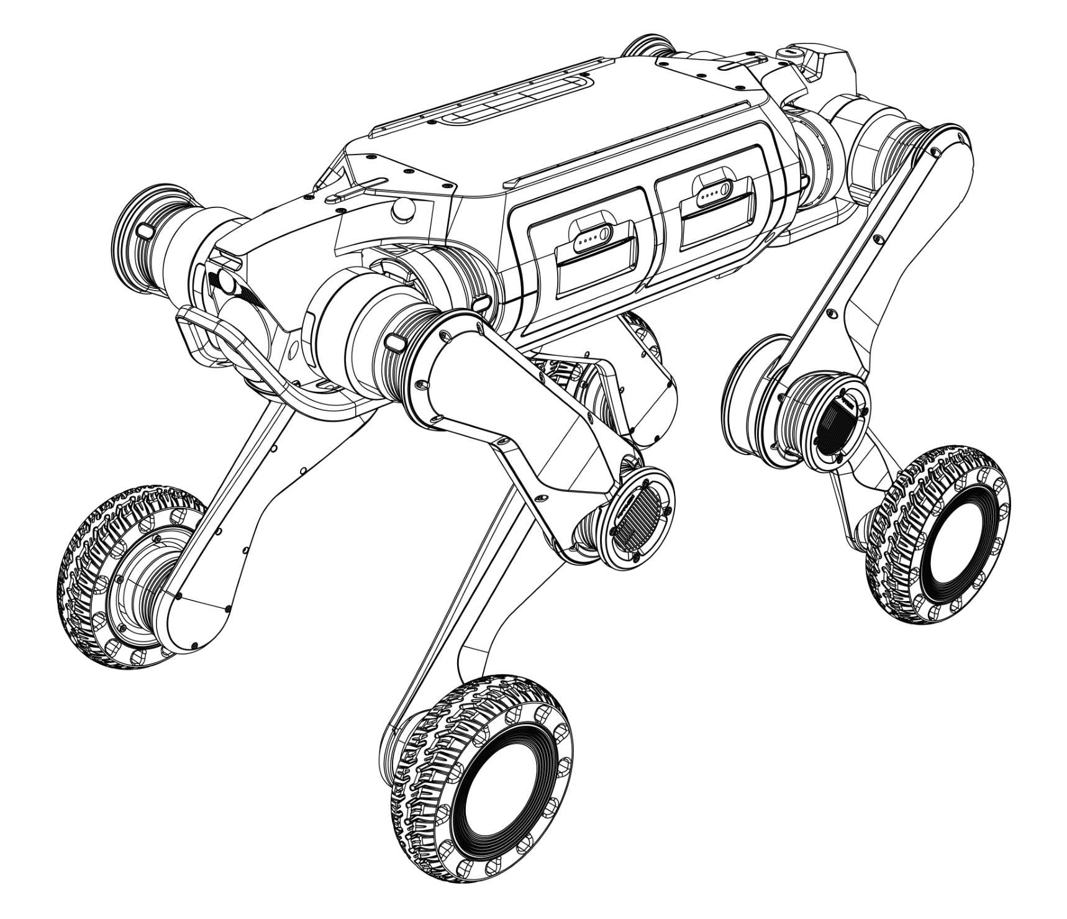
FX AEGIS MEGA D
User Manual

Statement
- This manual is the information asset owned by Faraday Future and any reproduction of part or all of this manual is strictly prohibited without the permission of Faraday Future.
- This manual explains the basic components, transportation and storage, specific operations, exception handling, and technical specifications of “Aegis Mega D”. Be sure to read and understand this manual carefully before operating the robot.
- Basic information on safe use is described in detail in the “Reading Tips”, so be sure to read this part thoroughly to ensure proper use.
- The diagrams and photographs in this manual are representative examples and may differ in details from the product purchased.ega
- This manual may be modified as appropriate for product improvements, specification changes, etc.
- The contents of this manual do not exclude the possibility of misremembering or omission. If this manual is damaged or lost or if you have questions about the contents of this manual, please contact us promptly.
- Failure caused by unauthorized disassembly or modification of the product by the customer is not covered by our warranty, see “Service & Warranty” for details.

Reading Tips

Description of Symbol
Before use (installation, transportation, maintenance, inspection), please be sure to read and master this manual, and familiarize yourself with the equipment and safety matters before you start using it. The safety matters in this manual are divided into three kinds: “Caution”, “Mandatory” and “Prohibition”. Even the contents of “Caution” may have serious consequences depending on the situation, so any of these safety matters are extremely important and should be strictly observed.
 | Caution | Usage tips or operational recommendations. Improper using or operating the robot may cause damage to it.
 | Mandatory | Matters that must be observed.
 | Prohibition | Matters prohibited. Misoperation is dangerous and may cause injury to operators or damage to the robot.

Get Help
For more resources to assist you in using Aegis Mega D proficiently, you can also visit the Faraday Future corporate website: https://robotics.ff.com/us/fx-aegis-mega/.

Important Safety Tips
Before starting the robot, please ensure that all people and objects present are more than 2 meters away from the robot to avoid collisions.

- When the robot passes through stairs or slopes, do not stand on the stairs, platforms, or slopes below the robot to avoid personal injury when it falls.
- When the robot swaying legs, shaking violently or other abnormal phenomena occur in use, press [STOP] button on the controller to activate the soft emergency stop protection, so that the moving robot enters a protective state. The robot will automatically get down. After identifying the problem, cancel Emergency STOP to operate the robot normally.

1 Introduction

1.1 Overview
Aegis Mega D is a wheeled-legged quadruped robot with 4 motors on each leg, a total of 16 degrees of freedom (DOF), and a variety of movement methods. The robot is equipped with 2 wide-angle cameras, 2 laser radars, and 3 industrial-grade high-performance hosts for motion control, environmental perception calculation, navigation and inspections.
-

1.2 Product List
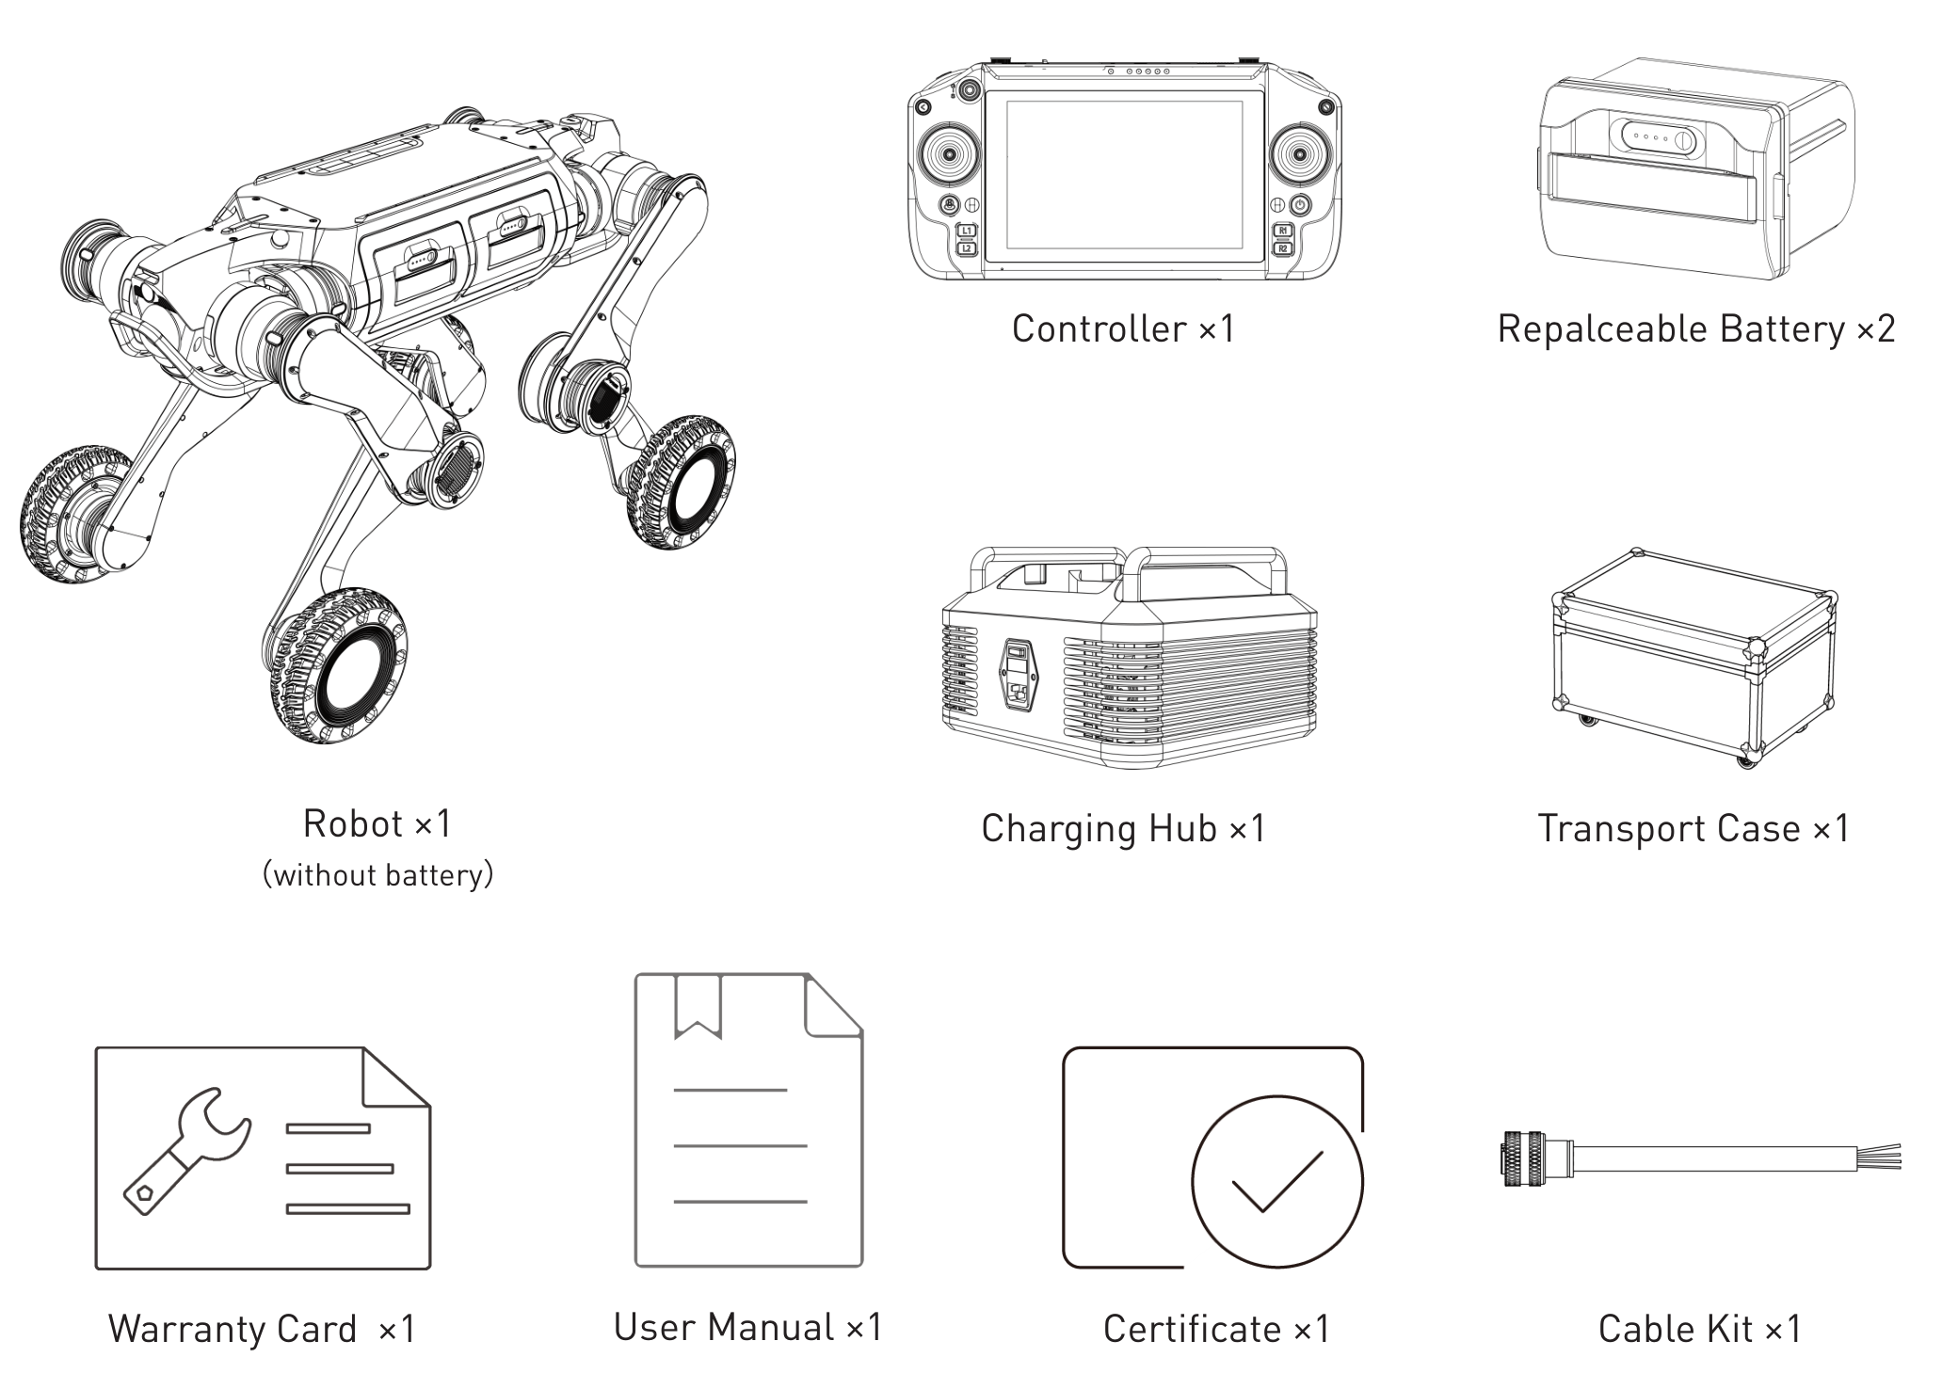

1.3 Product Parts
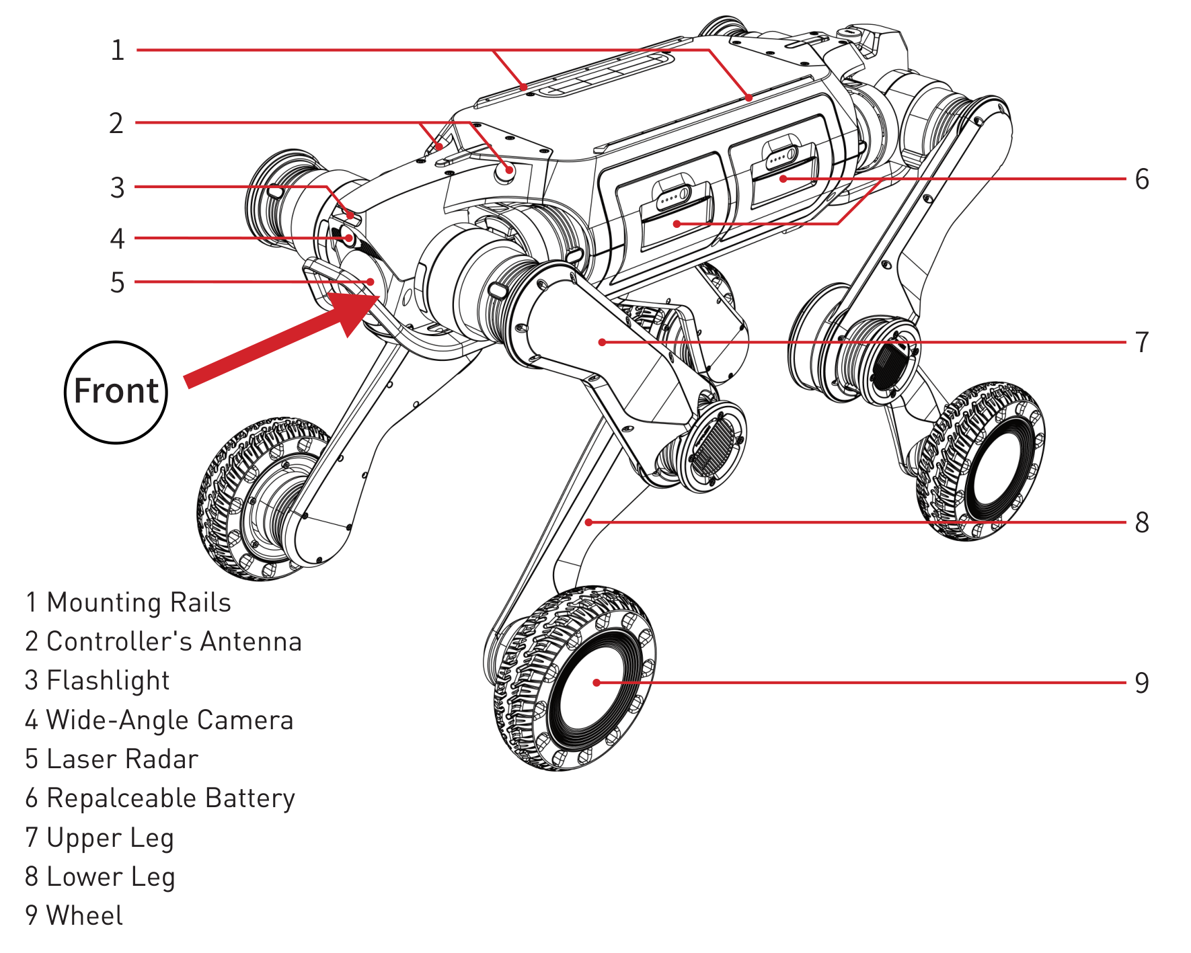
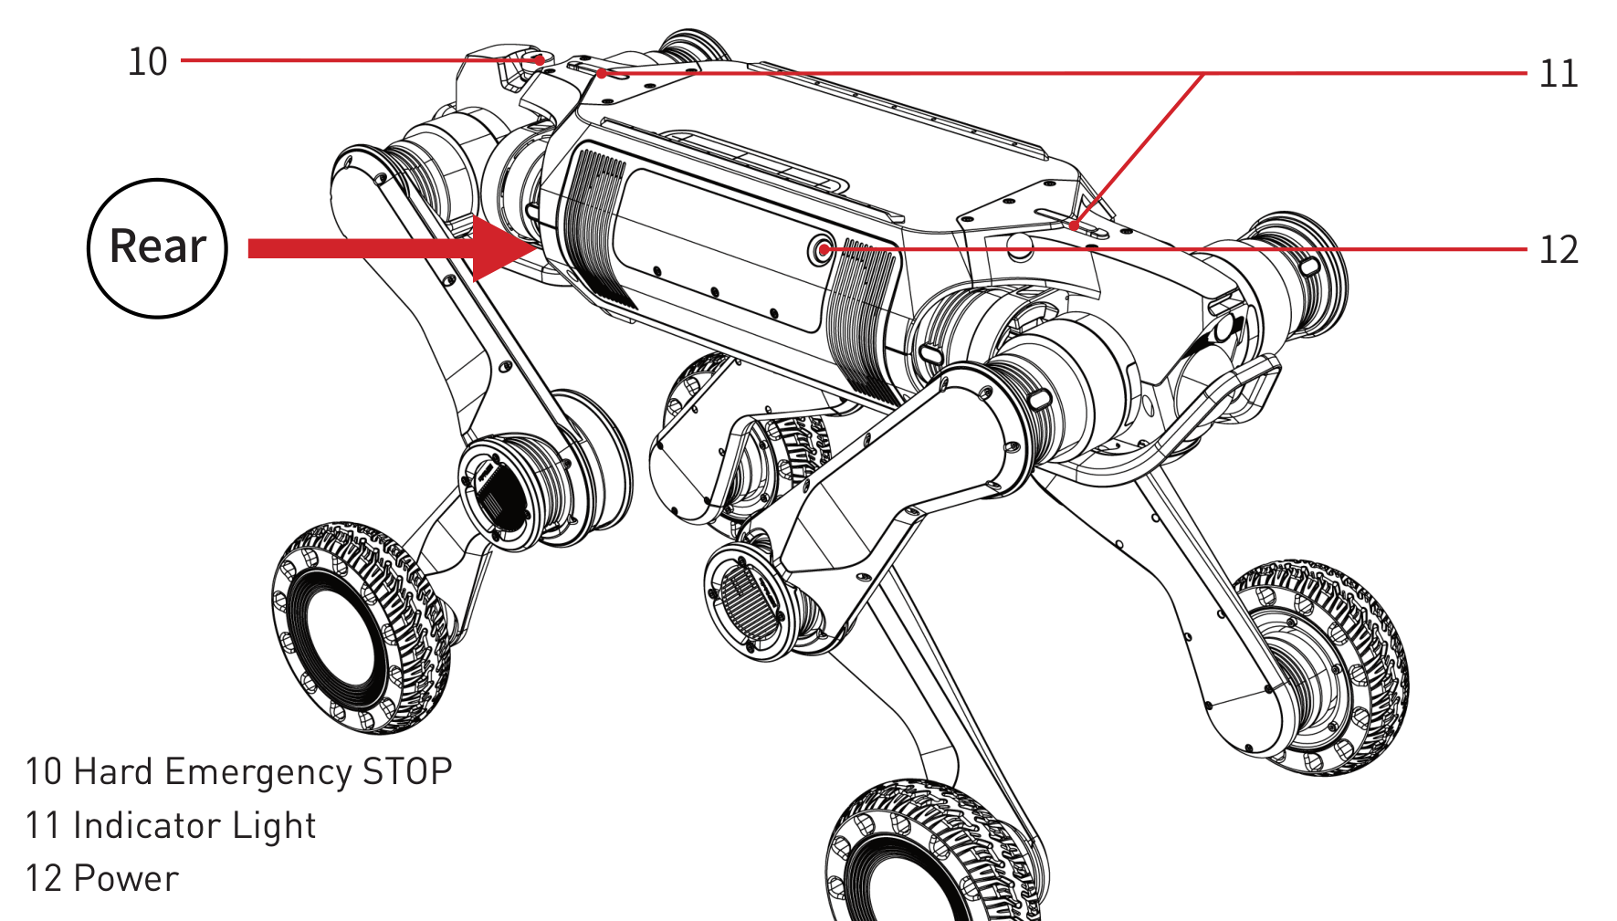
※The robot features a front–rear symmetrical design. The side with the controller’s antenna is the front of the robot, while the side with the hard emergency stop button is the rear.

1.4 Main Specifications
Robot Dimensions
Item | Value
Standing Size (Length × Width × Height) | 820mm×430mm×570mm
Sitting Size (Length × Width × Height) | 820mm×600mm×185mm
Tyre Size | 7 inches
Weight | 35kg

Electric Parameters
Item | Value
Battery Capacity | 4.5Ah (Each battery, ideal data in an environment at 25℃)
Nominal Battery Voltage | 72V
Charger Input Voltage | 100V~240V
Charger Output | 84/3A (for single battery)
Charging Time | 1.5h~2h (Each battery, supports simultaneous charging of dual batteries)
Power Supply | 72V; 24V; 5V (USB)
Communication Interface | Ethernet; WiFi; USB
Autonomous Charging | Supported (Optional)

Locomotion Parameters
Item | Value
Maximum Speed | 5.0m/s (Data from extreme test, which is not disclosed for safety reasons, and the actual product speed is limited to 3.0m/s)
Maximum Working Speed | 2.0m/s
Maximum Slope | ±45° (Varies depending on flooring material)
Maximum Continuous Stair Height | 25cm
Maximum Continuous Stair Slope | ±45°
Maximum Climbable Single Step Height | 80cm
No-load Runtime | 3h (Dual battery powered)
Payload Runtime | 2.5h (Dual battery powered)
Payload | 15kg
Maximum Payload | 50kg (Data from extreme test)

Sensor Parameters
Item | Value
LiDAR | ×2
Wide-angle Camera | ×2
Flashlight | ×2

Other
Item | Value
Ingress Protection | IP66 (With two batteries)
Operating Temperature | -20℃ ~ 55℃

※ Data above are measured under ideal conditions and dual battery powered mode, the actual results may be biased.

1.5 Description of Lighting

1.5.1 Power
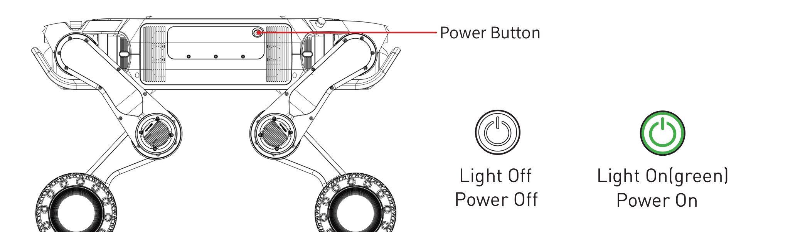

1.5.2 Battery
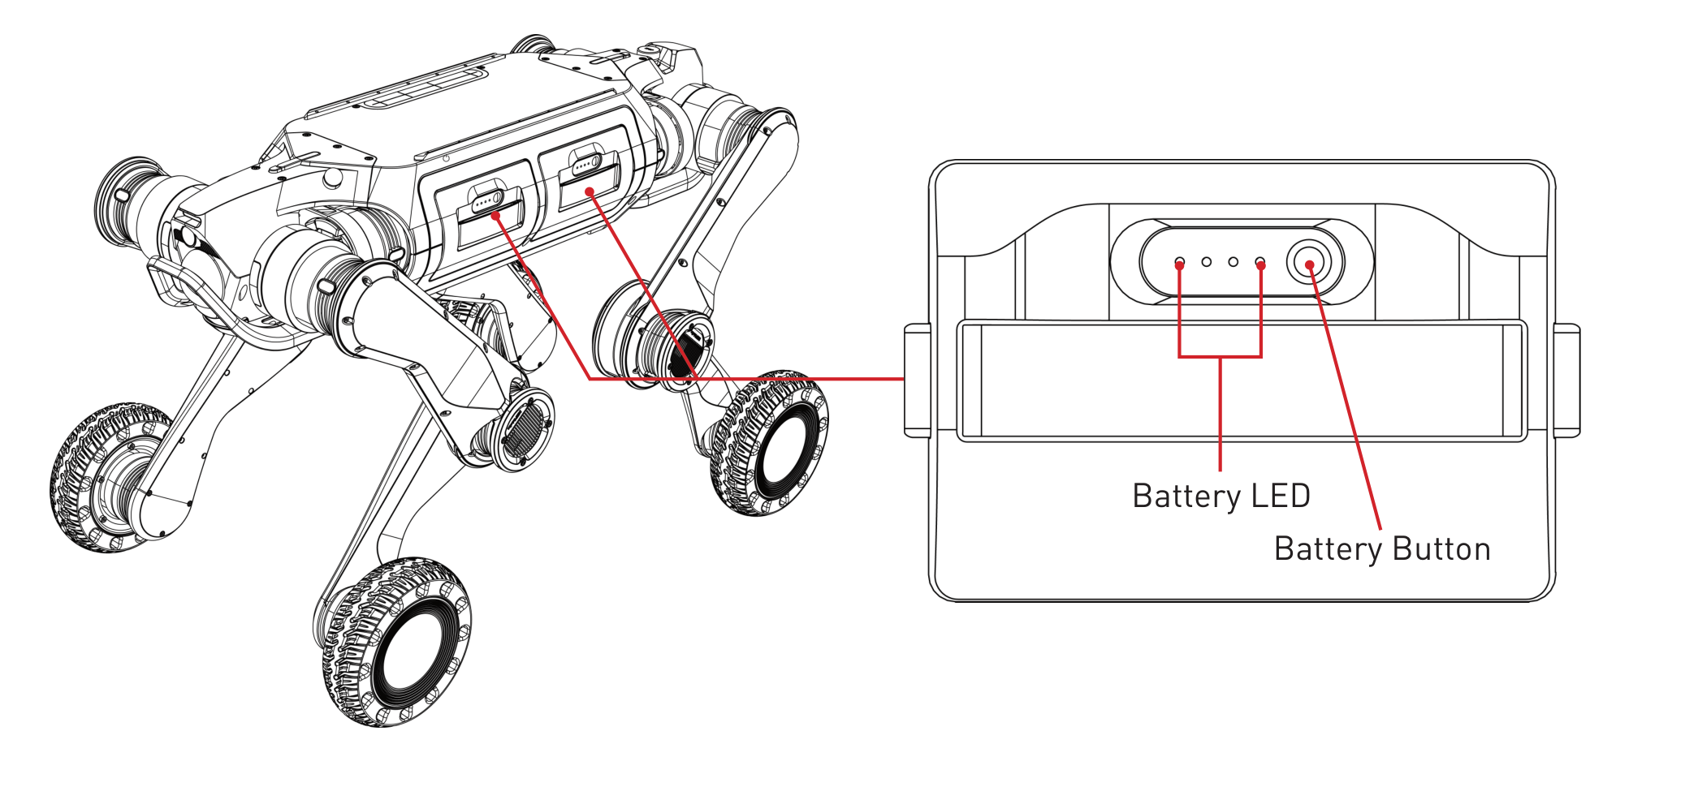
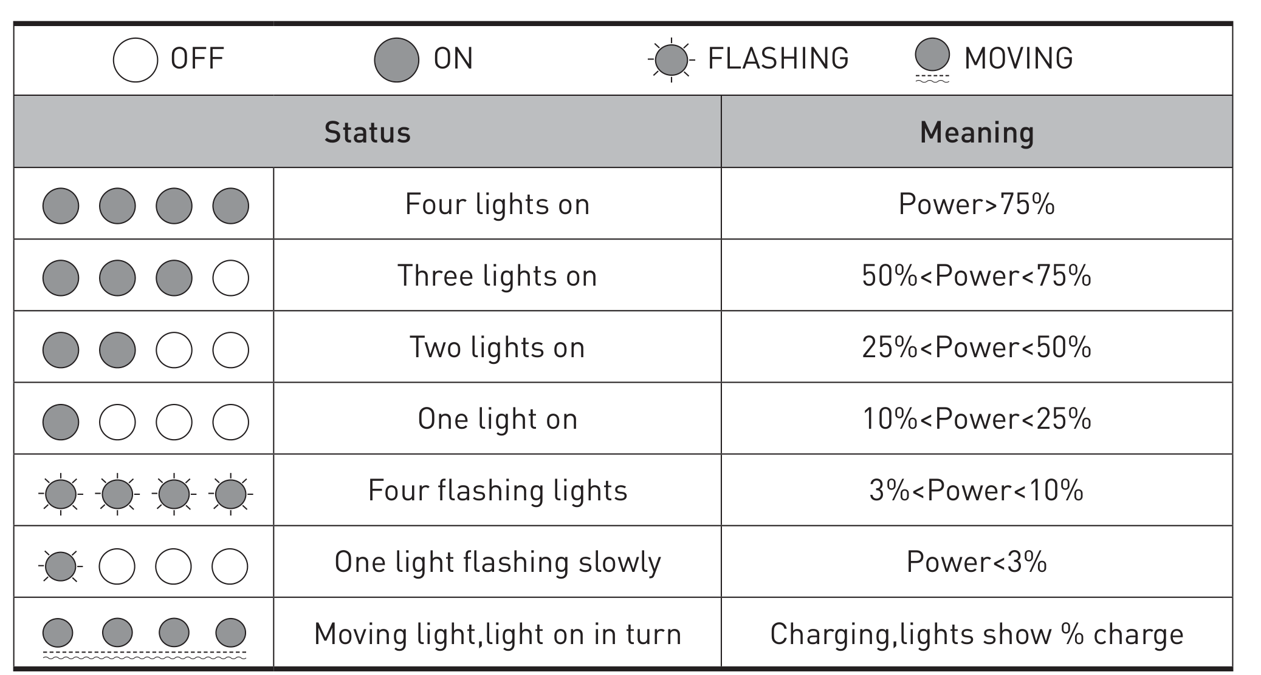

1.5.3 Indicator light
There is an indicator light on the front and rear of the robot’s back. The light language of the indicator light is shown below:
When only one indicator light is on:
Light Status | Robot Status and Meaning
White lights on | The robot is in regular mode
Blue lights on | The robot is using navigation and is in an autonomous standing or autonomous locomotion state

※Two indicator lights correspond to the head and tail directions respectively, and the illuminated light indicates the forward direction of the robot’s movement.
When two indicator lights are on:
Light Status | Robot Status and Meaning
White moving lights | The robot are waiting for the APP to connect or connecting
White lights on | Connected, and the robot is sitting
Green moving lights | The robot is charging on the charging dock, the number of lights illuminated indicates the battery level on the same side; the light being off indicates that the corresponding battery is not installed or powered. The battery not in the state of powered will not be charged
Yellow lights on | The robot is in hard emergency stop protection state  Continuous abnormal warning, you can view the specific abnormal warning information on the controller
Yellow flashing lights | In assist mode, the robot detects a risk of collision with surrounding obstacles.
Red lights on | Continuous abnormal protection, you can view the specific abnormal protection information on the controller

1.6 Mode and Gait
Usage Mode
Mode | Description
Regular | Robot is completely controlled by the user through the controller
Assist | The perception host will monitor the surrounding environment and assist the user in controlling the robot
Navigation | Robot moves autonomously and can not be controlled with the controller

Gait
Gait | Description
Basic | Suitable for conventional structured terrain (Max speed: 2.0m/s)
Stair | Suitable for climbing stairs, but not for walking on flat ground
High Obstacles | Supports climbing platforms not exceeding 80cm in height, but does not support climbing stairs

2 Operation

2.1 Preparation

2.1.1 Environment
- Please ensure that operators and non-operators present have read the manual carefully and understand the basic operating instructions and safety precautions.
- Before start the robot, ensure that all people or objects present are more than 2 meters away from the robot to avoid collisions.
- Please use the robot in an environment of -20°C ~ 55°C.

2.1.2 Carrying
Aegis Mega D weights approximately 35kg and it is recommended that two people carry it: One person stands at the front of the robot, firmly gripping both the lower and upper legs on each side with both hands; another person stands at the rear of the robot and adopts the same method to assist in completing the carrying task.
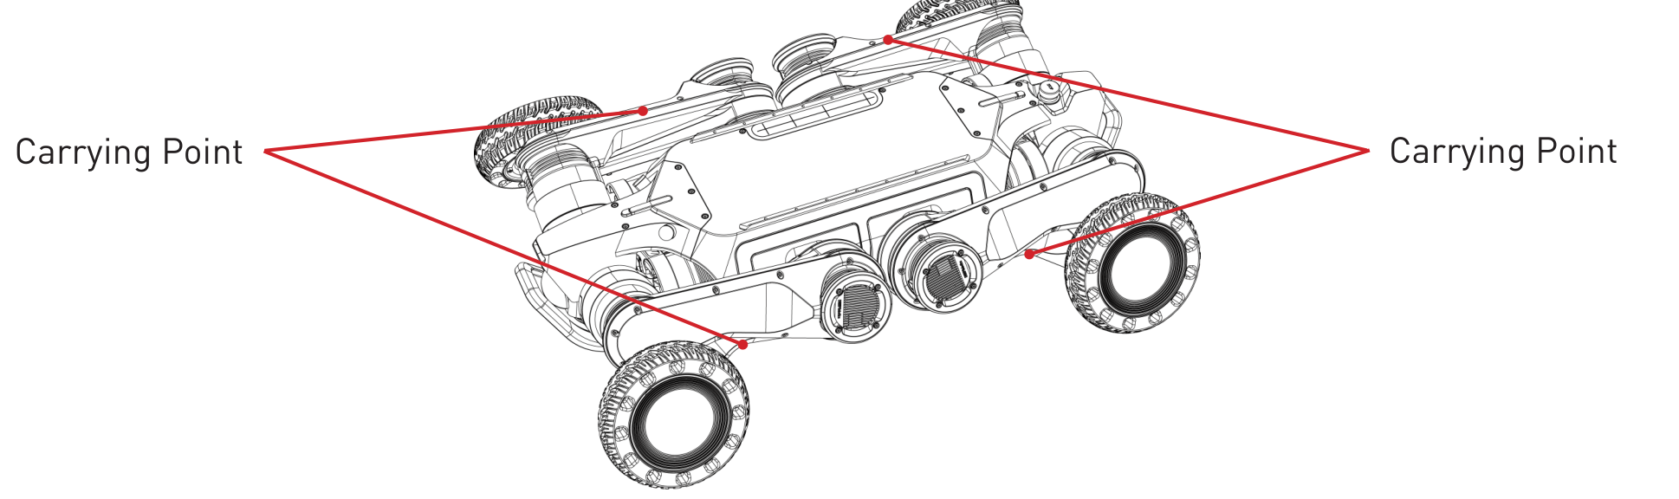
- Power off Aegis Mega D and carry it gently.
- Keep your hands away from easy pinch points and the range of motion of joints prevent pinching or scratching.
- The metal components of the robot’s legs that have just finished running are hot, so please wait until it cools down to suitable temperature before carrying.

The robot’s high temperature and pinch points are shown in the figure below:
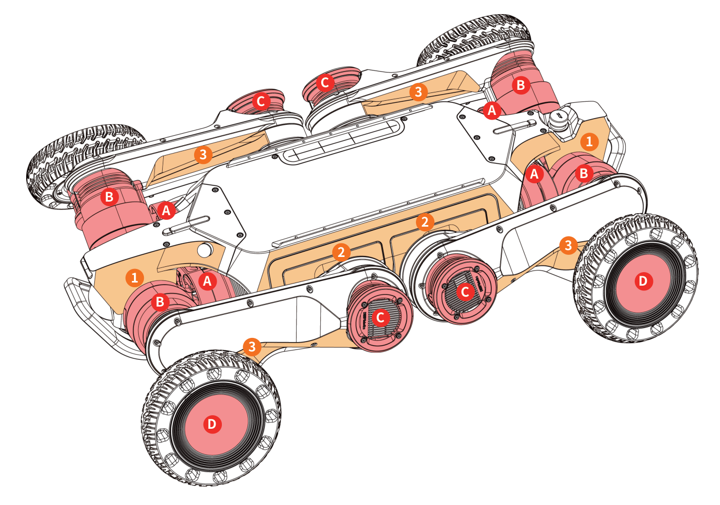
※Red letters indicate areas prone to high temperatures, and orange numbers mark easy pinch points.
※Ⓐ, Ⓑ, Ⓒ correspond to the HipX, HipY, and Knee joints, respectively. Ⓓ indicates the hub surface connected to the wheel joint. These areas, especially the joint modules and surrounding metal parts, may become hot after operation, DO NOT TOUCH!
※①: Gap between the shell of the head/tail and the adjacent joint. ②: Gap between the lower leg and the body side cover. ③: Gap between the upper and lower leg.
※Note: Pinch points on the right side of the robot are not fully marked in the diagram. However, since the robot is symmetrically designed, the right side mirrors the left.
※The pinch points listed above are not exhaustive. Please refer to 2.1.2 when carrying the robot.

2.1.3 Checking
- Press the power button once to check the battery. It is suggested to start the robot when both batteries are installed.
- Make sure the controller is fully charged.
- Make sure there is no visible damage to the exterior of the robot.
- Make sure the emergency stop button can be triggered.

If the robot parts are aging or damaged, please do not start the robot and contact the after-sales staff in time.

2.2 Charging
Aegis Mega D is powered by dual batteries, supports the replacement of any of these batteries while the robot is powered on. User can insert the battery into the charging hub for charging.
1. First, make the robot lie down, then lift the front/rear legs appropriately to ensure that the front/rear battery can be taken out smoothly. Hold the battery strap and pull it outward with appropriate force. The battery buckle will be unlocked by force, and then the battery can be removed from battery bin.
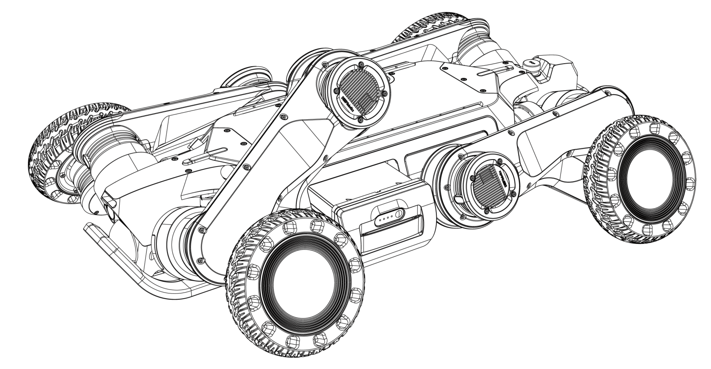
- It is recommended charge in an environment of 0°C ~ 40°C.
- During charging, please always pay attention to the battery and charging hub to prevent accidents, and disconnect the charging power in time after charging is completed.

2. Insert the battery into the Charging Hub (battery power button side facing inwards), then connect the Charging Hub to the mains (100V~240V), then turn on the Charging Hub’s switch for charging.
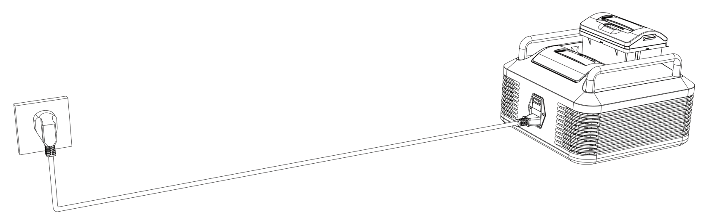
3. When charging, the battery LED lights will in a moving state and light on in turn, the number of lights on corresponds to the power already charged.
4. After finishing charging, the four battery LED lights off and the charger’s light will turn green.

2.3 Start

2.3.1 Preparation
1. First, take the robot from the transport case and place it on a flat surface, as described in the section “2.1.2 Carrying”.
2. When installing the front battery, lift the front legs appropriately to ensure that the battery can be inserted smoothly. When inserting the battery, it is necessary to place the battery forward into the battery bin (the battery LED and battery button above the battery strap). Pull the battery strap outward with one hand to unlock the battery buckle; lift the bottom of the battery slightly with the other hand and push it into the battery bin with appropriate force. Then loosen the battery strap, when the buckles on both sides of the battery strap are inserted into the battery bin, it indicates that the battery has been successfully installed. The rear side battery can be installed in the same way.
3. Adjust the robot pose as required (as shown in the picture below): Upper leg is tightly pressed against the lower leg, the lower leg and wheel naturally touch the ground.
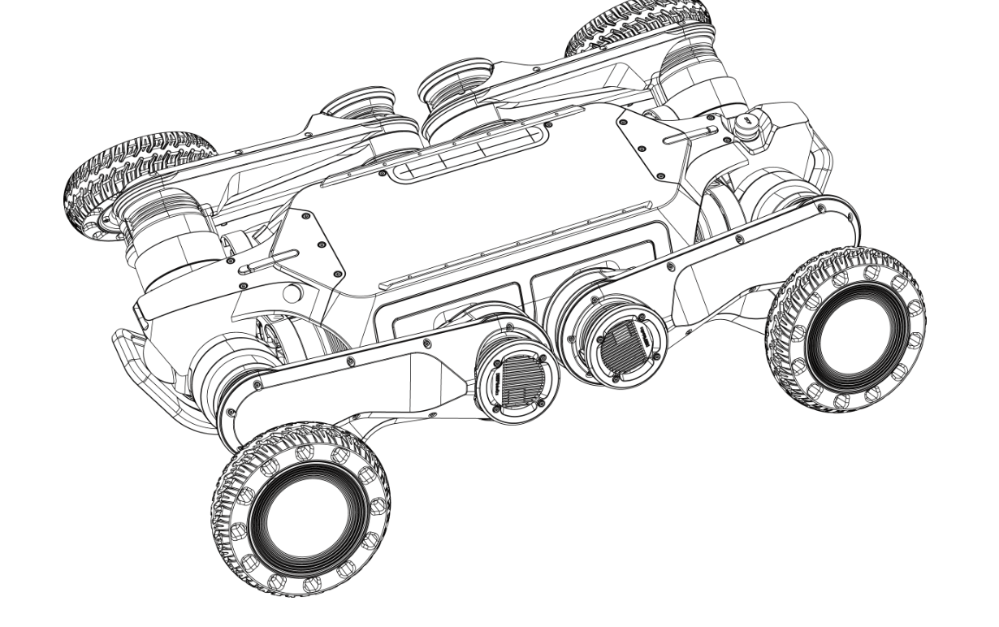

2.3.2 Power on
Before power on the robot, please confirm that the hard emergency STOP button has not been triggered. If the hard emergency STOP button is triggered, troubleshoot the robot first. After ensuring that the machine can be operated normally, rotate the button in the direction indicated by the arrow on the button to release the hard emergency stop.
With the hard emergency STOP button not triggered, press, then press and hold the battery button until the battery LED flashes and stays on, indicating that the battery is powered, and the battery LED light shows the current battery level. Press the power button on the right side of the robot to start the robot. At this time, the power switch always lights up green.

2.3.3 Connection
Press and hold the power button to turn on the controller (please ensure that the controller has enough power before use). The robot and controller have been paired and bound. After opening the “Faraday Future” app, the controller will automatically connect to the robot it is bound to. | -

2.4 Controller Operation
After starting the APP, you will automatically enter the control interface, as shown in the figure below:
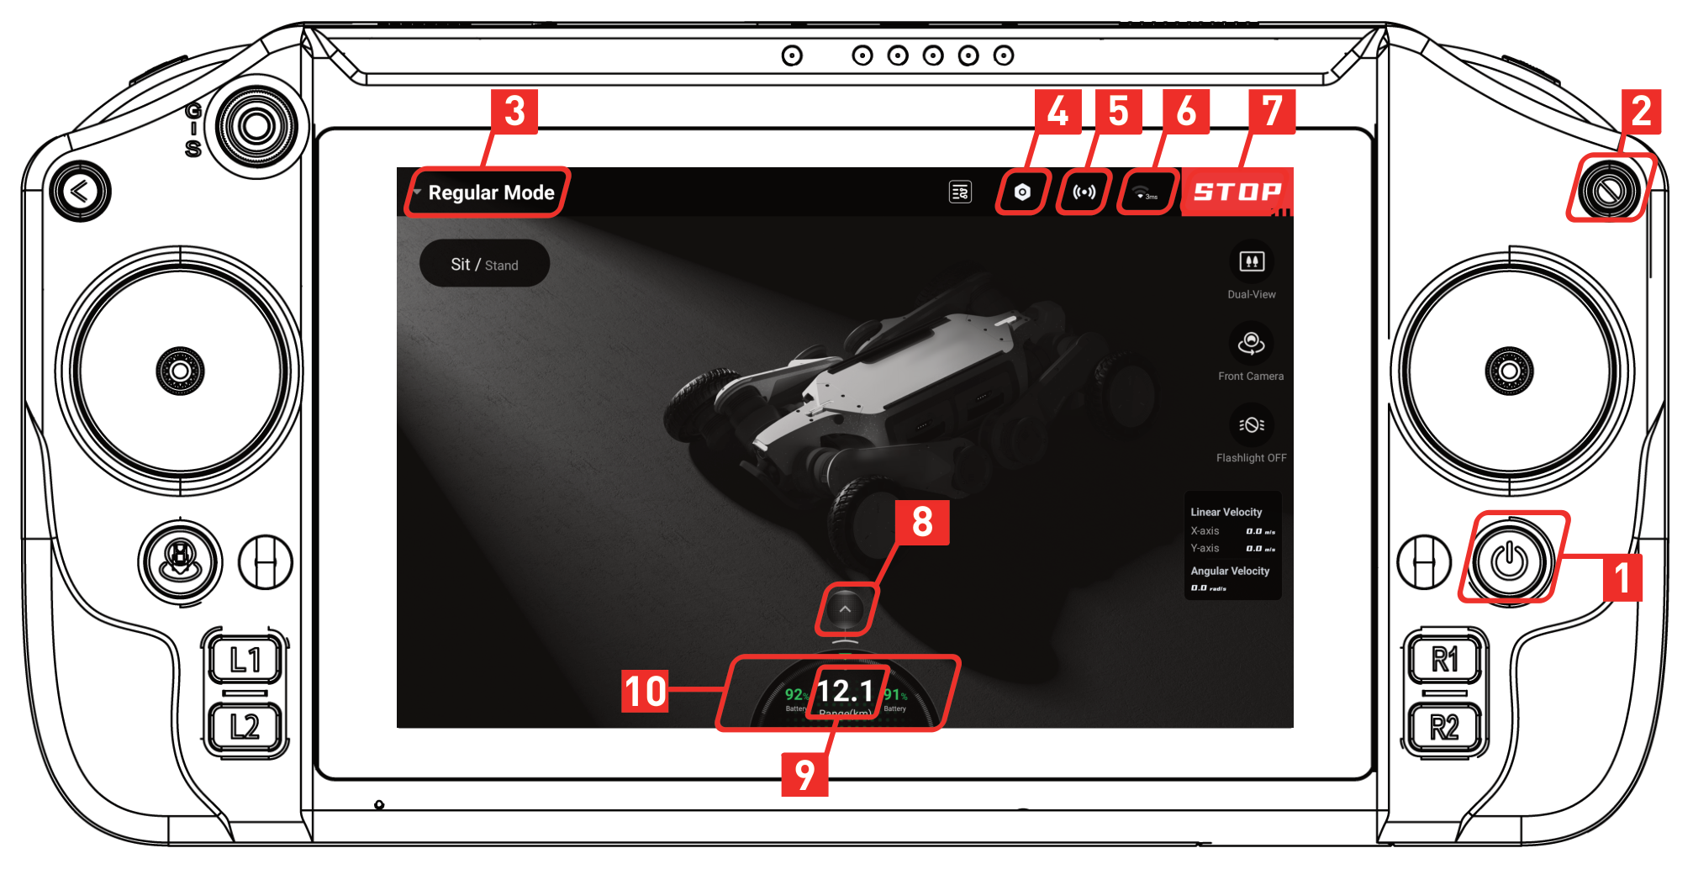
Button
No. | Name | Function
① | Controller Power | Press and hold to power on/off, and press once to wake
② | STOP | Trigger the soft emergency stop and force the robot to lie down. Typically used when the robot is out of control or in emergency situations
③ | Control Mode | Press to switch control modes: Regular / Navigation / Assist
④ | Settings | Settings: About Device / Sensor / Status / Accessibility & Convenience
⑤ | LiDAR | Indicates that the dual LiDAR is enabled. To enable this function, go to ‘Settings – Sensor Management’
⑥ | Robot Signal | Visible only when the controller is connected to the robot, showing connection signal strength and latency information
⑦ | STOP | Soft Emergency Stop
⑧ | Expand / Close | Press to expand / close robot dashboard
⑨ | Remaining | Estimated Remaining Operating Range
⑩ | Battery Information | Left and right values indicate the remaining battery percentage of the front and rear sides

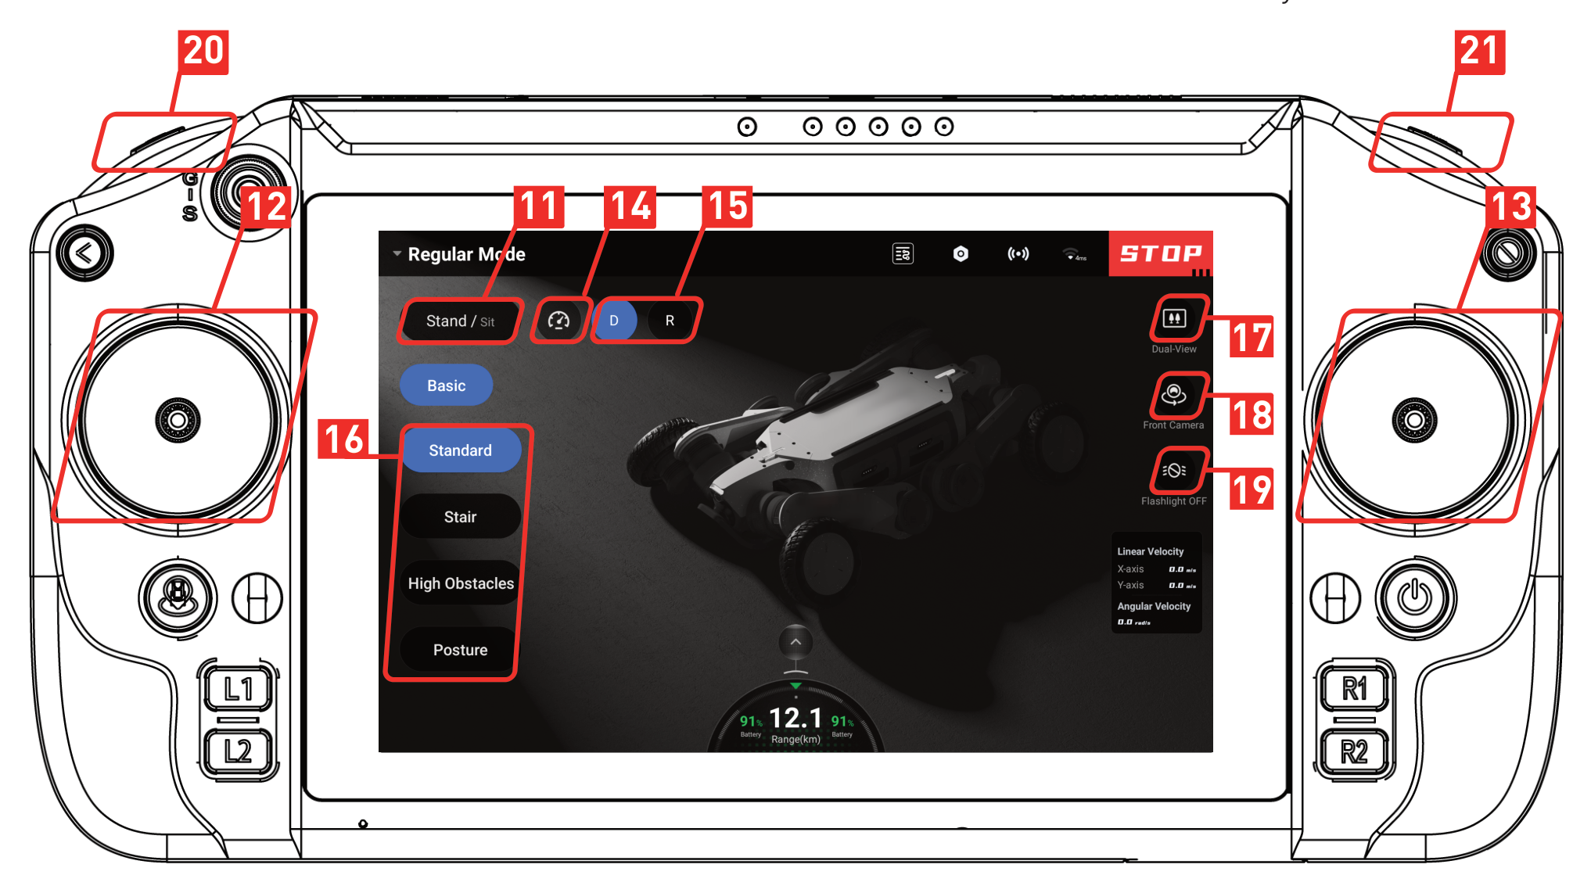
Button
No. | Name | Function
⑪ | Sit/Stand | Stand up or sit down, and the button displays the current status
⑫ | Left Joystick | Control the robot to translate
⑬ | Right Joystick | Control the robot to rotate
⑭ | Speed Adjustment | Press the gear icon to enable speed adjustment. Slide the slider to set the maximum speed
⑮ | Change Direction | Press to switch movement direction: Forward / Reverse. The current state is highlighted in blue
⑯ | Gait | Press on the gait name to switch gait. The gait displayed in blue is the current gait
⑰ | Camera | Press to switch the number of camera video streams: Single-View / Dual-View
⑱ | Camera View | Press to switch the camera video streams displayed on the main interface: Front View / Rear View
⑲ | Flashlight | Press to control the lighting mode: Flashlight OFF / Front Flashlight / Rear Flashlight / All Flashlights
⑳ | Photo | Save images from the video streaming
㉑ | Video | Record a video of the video streaming

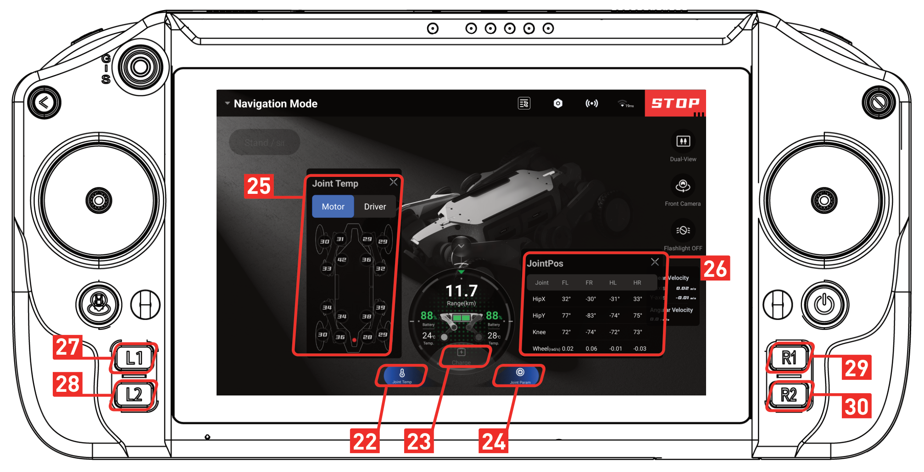
Button
No. | Name | Function
㉒ | Joint Temperature | After pressing, the switch will be highlighted in blue and the joint temperature panel will be displayed
㉓ | Charge | After pressing, the robot automatically switches to navigation mode and executes autonomous charging tasks
㉔ | Joint Parameters | After pressing, the switch will be highlighted in blue and the joint parameters panel will be displayed
㉕ | Joint Temperature Panel | Display joint temperature information. Press on the motor/driver to switch to view the joint module temperature. Warn/Error of the motor/driver is displayed in orange/red respectively
㉖ | Joint Parameters Panel | Display joint movement parameter information
㉗ | L1 | Make the robot stand up or lie down, same as button ⑪
㉘ | L2 | Switch main screen camera view, same as button ⑲
㉙ | R1 | Shortcut key, set it in “Settings – Accessibility – Shortcut Key”
㉚ | R2 | Shortcut key, set it in “Settings – Accessibility – Shortcut Key”

2.5 Setting Operation
After starting the APP, press the [④ Settings] button to enter the settings interface, as shown in the figure below:
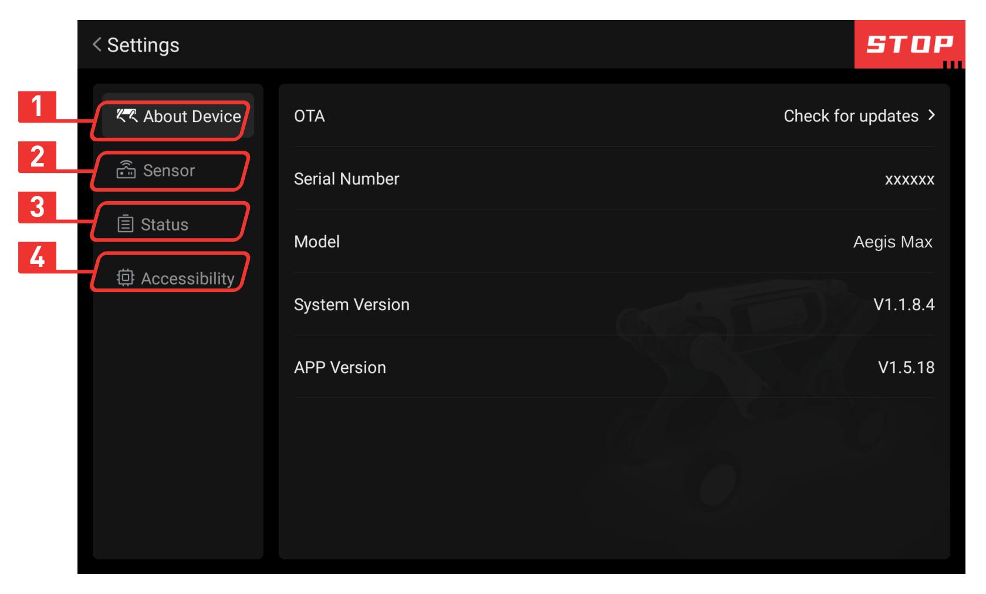
Button
No. | Name | Function
① | About Device | View: Serial Number / Model / System Version / APP Version, and perform OTA
② | Sensor | Can enable or disable: LiDARs / Wide Angle Cameras
③ | Status | View: Motion / Posture / CPU / Battery status
④ | Accessibility | Set: WiFi / Shortcut Key / Language

2.6 Marking Tool

2.6.1 Enabling the Marking Tool
Press [④ Accessibility] button on the control page to open the route list panel.
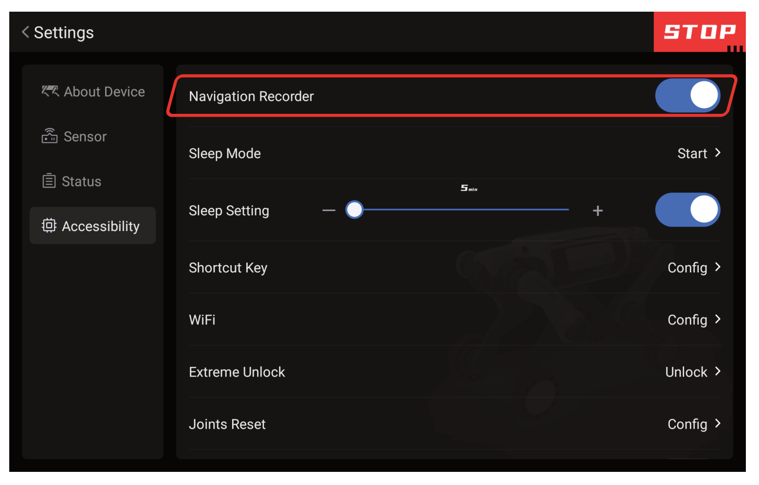

2.6.2 Marking Tool Operation
After starting the APP, press [① Marking Tool] button to enter the route list interface as shown below:
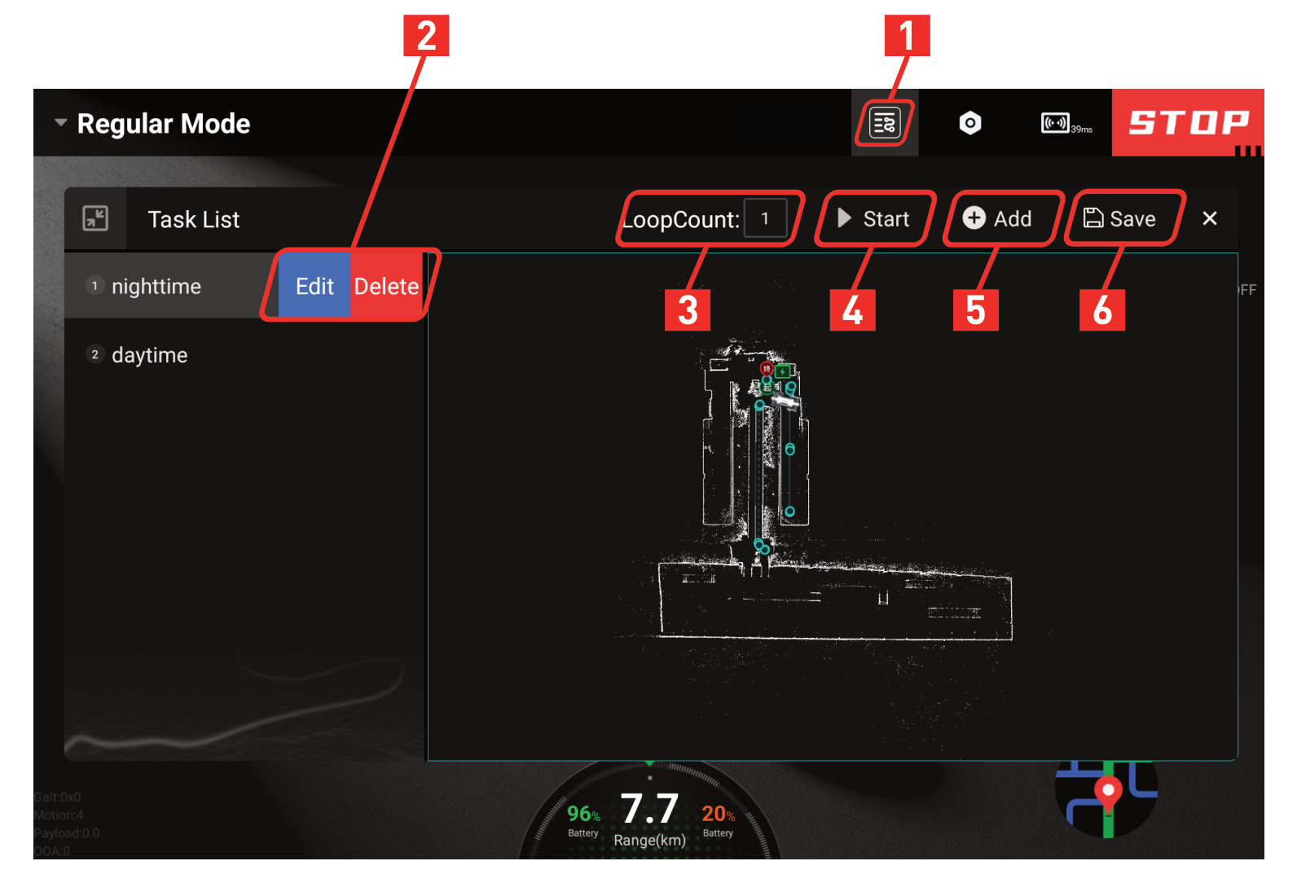
Button
No. | Name | Function
① | Marking Tool | Press to enter the route list interface.
② | Edit/Delete | Press to edit/delete a route.
③ | LoopCount | Press to set the number of times the robot repeats a single route.
④ | Start | Press to start executing the route; press again during execution to stop.
⑤ | Add | Press to add a new route at the end of the route list.
⑥ | Save | Press to save the current route list.

After pressing [Edit Route] or [Add Route], enter the route settings page.
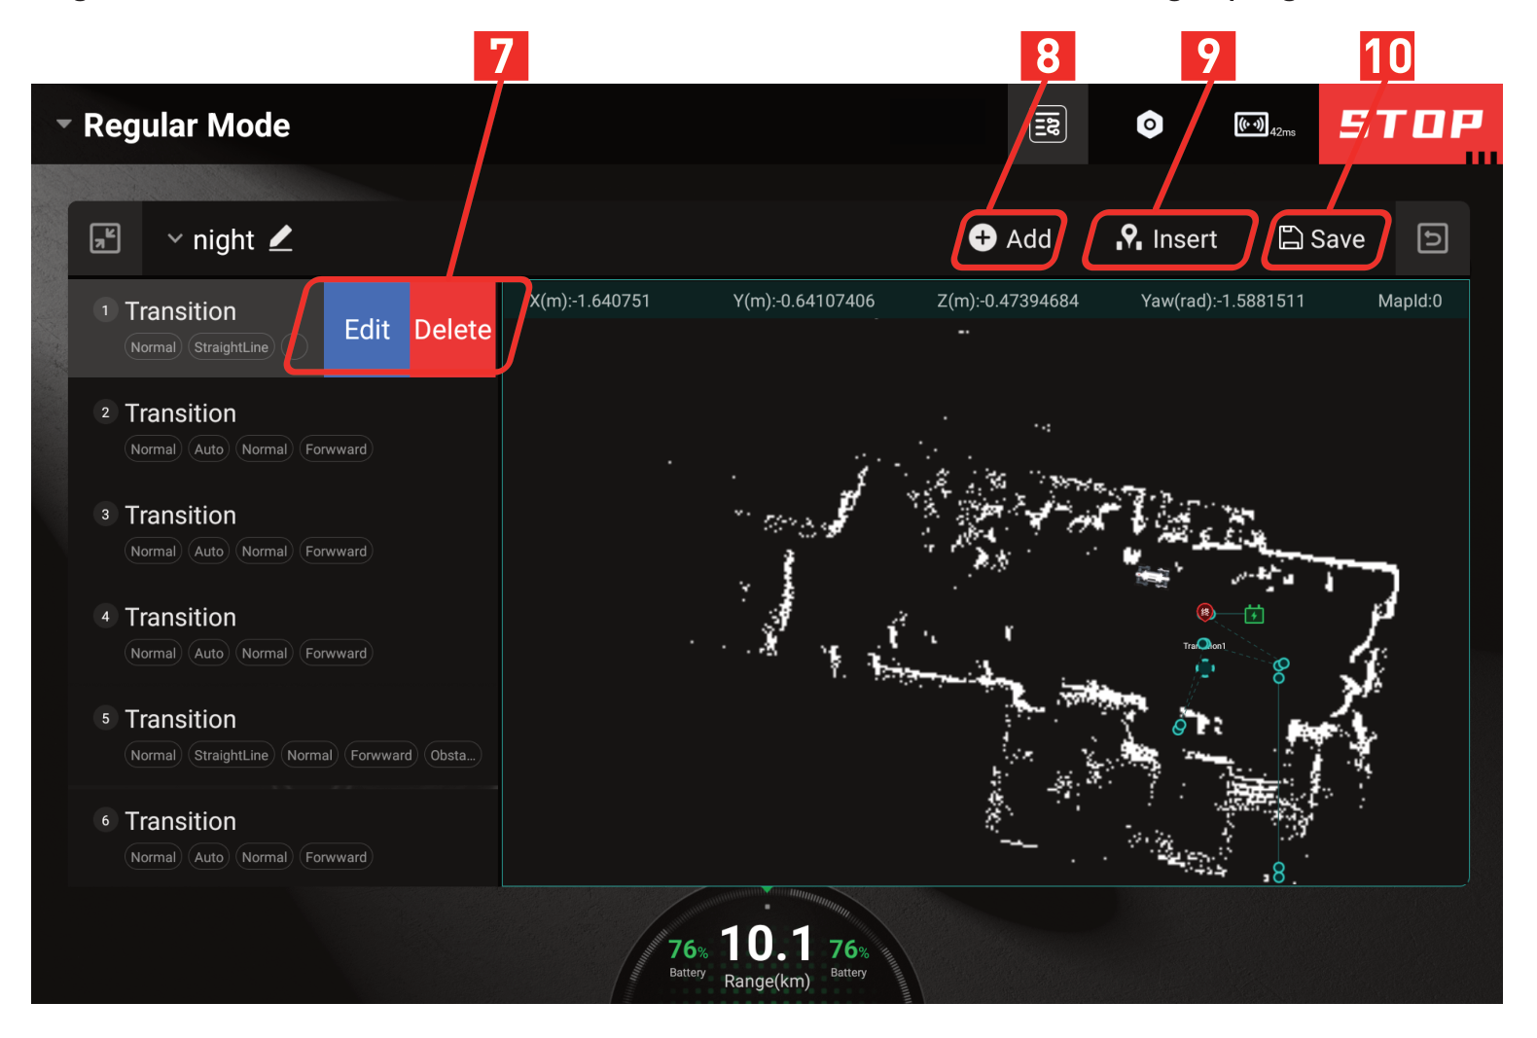
Button
No. | Name | Function
⑦ | Edit/Delete | Press to edit/delete a waypoint.
⑧ | Add | Press to add a waypoint at the end of the list.
⑨ | Insert | Press to insert a waypoint before the currently selected waypoint.
⑩ | Save | Press to save the current route.

After pressing [⑧ Add Waypoint] or [⑨ Insert Waypoint], enter the add waypoint settings page.
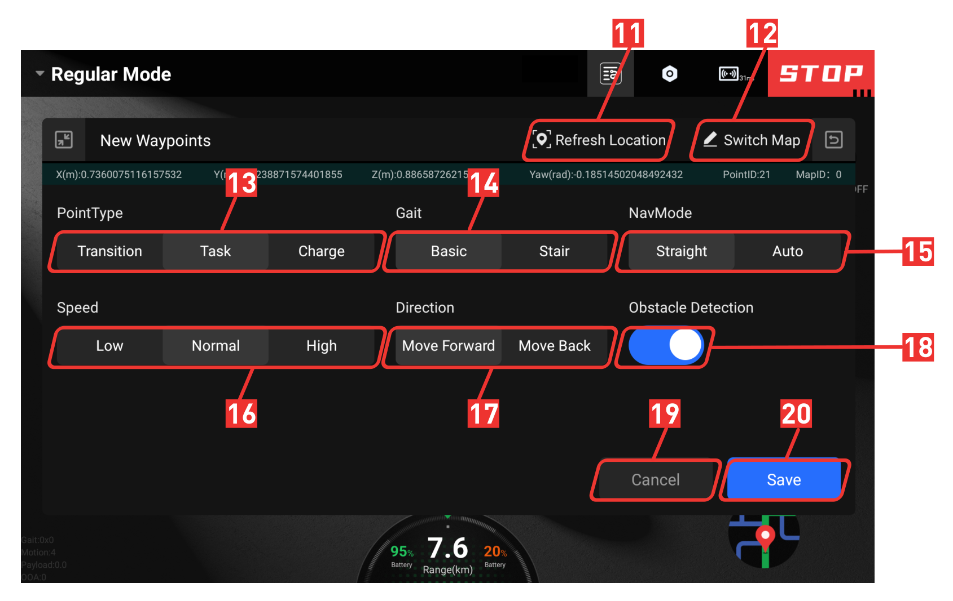
Button
No. | Name | Function
⑪ | Refresh Location | Press to get current coordinates: the bar below turns green on success, red on failure.
⑫ | Switch Map | Press to modify the map ID.
⑬ | PointType | Press to switch waypoint type: Transition / Task / Charge; highlighted item is the selected type.
⑭ | Gait | Press to switch gait type: Basic / Stair; highlighted item is the selected type.
⑮ | NavMode | Press to switch navigation mode: Straight / Autonomous; highlighted item is the selected mode.
⑯ | Speed | Press to switch movement speed: Low / Normal / High; highlighted item is the selected speed.
⑰ | Direction | Press to switch movement direction: Move Forward / Move Backward; highlighted item is the selected direction.
⑱ | Obstacle Detection | Press to enable/disable obstacle detection; the button is highlighted in blue when enabled.
⑲ | Cancel | Press to cancel the current waypoint setting operation.
⑳ | Save | Press to save the current waypoint settings.

2.7 Emergency Operation

2.7.1 Soft Emergency Stop
If the robot’s legs swing or shake violently and other abnormal phenomena occur during use, please start the soft emergency stop function on Controller to make the robot lie down. After troubleshooting, press the stand button again to operate the robot normally.

2.7.2 Hard Emergency Stop
Hard emergency stop button disables the joints power. Press the hard emergency stop button at the back rear of the robot, and the power button indicator light is off to indicate that the hard emergency stop has been triggered, which can avoid the robot from getting out of control. After troubleshooting the problem, if you need to release the hard emergency stop, please rotate the hard emergency stop button in the direction of the arrow on the button to release the hard emergency stop. If the hard emergency stop button pops up, it means that the hard emergency stop has been released. After the hard emergency stop is released, the robot will automatically restart, and the controller will be temporarily disconnected. Once the robot has successfully restarted, the controller will automatically reconnect to the robot and the robot can continue to be used.
Once the hard emergency stop is triggered, it will cause the robot to lose all kinetic energy and thus fall to the ground. There is a risk of damaging the ground or the robot, so it is strictly forbidden to press the hard stop emergency button during normal movement!

2.7.3 Overtemperature
The system comes with temperature sensing. Once the robot runs for a long time and causes the motor, driver, battery or CPU to overheat, it will automatically enter the overheat protection state, and the robot will automatically stop moving and lie down on the spot. Wait for the robot to cool down and exit the overheat protection state before continuing to operate the robot.

2.7.4 Low Battery
When the robot’s battery is below 20%, it will enter a low battery warning state, charge the robot immediately or replace the battery. When the battery level drops below 5%, the robot will trigger a low battery protection mode, where it will automatically lie down and will no longer respond to commands from the remote controller. Please replace the battery before continuing to use it.

2.7.5 Other Circumstances
- If the joints are still swinging after the robot falls down suddenly, wait 30 seconds after the robot joints have completely stopped moving before pressing the hard emergency stop button at the rear of the body.
- In case of a fire, do not use water to extinguish it. Please use foam fire extinguisher, dry powder fire extinguisher or carbon dioxide fire extinguisher nearby.
- If the soft emergency stop fails, robot smokes or is submerged in water, or other unexpected situations, please immediately power off the robot and wait until it’s safe to identify the problem. Then please contact Faraday Future, and we will help to troubleshoot the problem and repair or change your robot. Pay attention to safety in use!
- If the robot falls, do not drag, push or flip it before triggering the hard emergency stop.

2.8 Power Off
Make sure that the robot is sitting before the following operations.

Press the robot power button, the power button pops up, the power light and indicator light go out, and the robot shuts down. Press, then press and hold the battery power button until the battery LED light flashes once. Then the battery indicator light goes out, indicating that the battery has stopped providing power and the shutdown is complete.

2.9 Payload
The robot supports payloads installation and development. Users can screw devices into the thread holes on the back of robot (unit: mm).
The installation range of the load is limited to the area where the mounting rail is located, and the height is limited to 30cm, that is, the available installation range is 270mm × 165mm × 300mm. It is recommended that the weight of the mounting devices should not exceed 15kg.
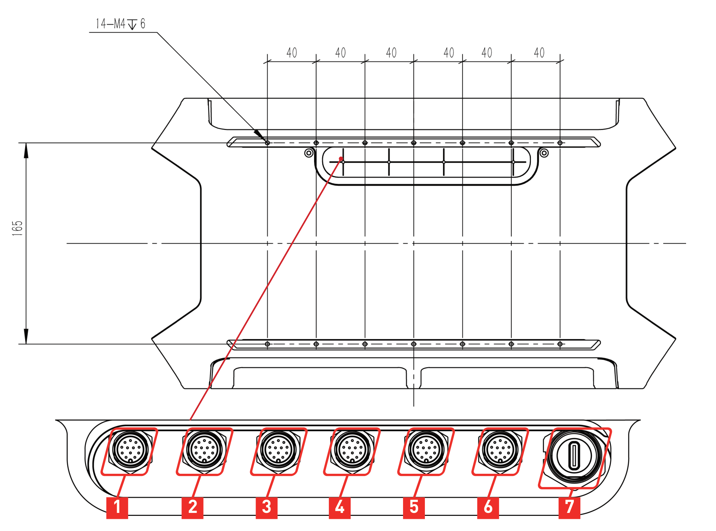
Interface
No. | Interface | No. | Interface
① | 72V | ⑤ | LAN4+24V
② | LAN1 | ⑥ | LAN5+24V
③ | LAN2+24V | ⑦ | USB (Type-C)
④ | LAN3+24V

- When mounting devices on the back of the robot, the robot’s motion performance may be affected. Please be sure to consult the after-sales personnel before installing.
- The maximum power supplied by the robot to the payload is 360W. Total power of 24V power supply not exceeding 250W.
- Please cover the aviation plug with its cover.

3 Precautions

3.1 Work Environment
- Do not operate the robot in environments with strong electromagnetic interference such as high-voltage cable, high-voltage transmission stations, base stations and television broadcasting towers, etc.
- Please do not operate the robot in environments with strong WiFi signal interference. Be sure to turn off all other WiFi signal source, and then use the joystick to operate the robot.
- Do not operate the robot in bad weather with fog, snow, lightning, sandstorms, windstorms, tornadoes, etc.
- Keep the robot in sight and keep it at least 2 meters away from people, water, open flames, etc at all times.
- Do not use robot on smooth surfaces such as ice, glass and tiles. If need to pass through smooth surfaces, please avoid violent movements to prevent the robot from slipping and falling.
- Do not run the robot on the edge of a high place to prevent it from falling from a height and causing damage.

The robot is IP66 protection rating only when two batteries are installed at the same time. The robot can completely prevent dust from entering and can withstand powerful water jets without harmful water penetration. But it does not support immersion, as damage caused by liquid infiltration due to immersion is not covered by the warranty. If water splashes, please wipe off the water stains on the surface of the equipment after use and store it. If the robot falls into water or is submerged in liquid, please stop using immediately, wipe off surface water stains, and contact after-sales for support.

3.2 Battery
- Before using the battery, carefully read the instruction manual and battery labels on the surface.
- Need to use the original battery charger (such as Official Charging Hub, etc).
- Do not drop or strike batteries. Do not place heavy objects on the batteries or charger.
- Never use the battery in a humid environment and never immerse it in water or get it wet.
- When water is touched inside the battery, a decomposition reaction may occur, which may cause the battery to self-ignite or even explode. It is strictly forbidden to expose batteries to any liquid, never immerse them in water or get wet, and keep away from rain or wet environment. If the battery accidentally falls into water, immediately place the battery in a safe open area and keep it away from the battery until it is completely dry. Drying batteries should not be reused.
- Disassembly of batteries without authorization is prohibited. Once disassembled, no warranty is granted. Faraday Future is not responsible for battery accidents caused by privately disassembling batteries.
- Do not short-circuit the battery positive and negative.
- If not in use for a long time, please remove the battery from the robot, store it separately and charge it to 60%, so as to avoid over-discharging of the battery, which may cause damage to the battery cell and make it impossible to continue to use.
- Press and hold the battery button for 20 seconds until the battery indicator light flashes 5 times to put the battery into Storage Mode.
- In the Storage Mode, the battery can be stored for a long time, and it does not respond to the press operation of the button and the battery indicator light is always off. Charging the battery to exit the Storage Mode.
- When the battery is left for more than 3 months, it should be recharged to 60% to keep the battery active.
- If battery exhibits overheating, leakage, unusual odors, deformation or other anomalies in use or during storage, please stop using it immediately and stay away from the battery, and contact after-sales for further processing.
- Please refer to the battery instructions for details.

3.3 Other Precautions
- When carrying the robot, pay attention to the anti-pinch label on the robot and do not put your hands into the position where the anti-pinch label is attached!
- Do not lift the robot while it is moving to avoid unintended movements that could cause damage to robot or injury to people!

- Please do not download other unrelated APPs in the controller.
- It is strictly forbidden to disassemble the robot personally. Once disassembled, the warranty will be invalid!

4 FAQs
Q1: Is it normal for a robot to stop moving on its own?
A: Probably some kind of abnormality caused the robot to trigger its own protection mechanism, you can check the specific operation tips through the controller’s APP. If it continues to fail to return to normal or does not display the abnormal handling prompts, please contact the after-sales service.
Q2: What if there is no response to the commands from APP after connected?
A: First confirm if the hard emergency stop is off. If the APP is still unable to control the robot, please restart the robot.
Q3: Can the robot continue to be used when its body or legs are askew after standing up?
A: At this time, do not control the robot to move. Please immediately trigger soft emergency stop to make the robot lie down. Then shut down and restart to try to control the robot to stand up again. If still abnormal, please contact the after-sales staff.
Q4: What if the robot falls down due to the loss of control of one of its legs?
A: First press [STOP] button on the controller to make it down. Then restart the robot. If it does not return to normal after restarting, please contact after-sales staff.
Q5: What if the video stream gets stuck after the robot falls?
A: Restart the robot. If the video stream is still black, please contact after-sales staff.
Q6: Is it normal that the battery LED lights are not lit after pressing the battery power button?
A: It may be that the battery has entered Storage Mode. Please refer to “2.2 Charging” to charge the battery and then try to see if the battery can be used normally. If it still cannot be used, please contact after-sales service.
Q7: What terrain can the robot adapt to?
A: The robot can be applied to gently uneven ground such as flat land and grass, and can also climb complex terrain such as stairs and slopes, but please avoid operating and using the robot in extreme terrain (such as too smooth surfaces such as ice, sharp or undulating terrain, near high edges, etc.).
Q8: What if encountering a problem that cannot be solved even after consulting this manual?
A: Please contact the after-sales staff promptly for help.

5 Transport & Storage

5.1 Transportation
When transporting the Aegis Mega D, please use the transport case specifically designed for it.
Before shipping the robot with transport case, remove the batteries from the robot. And when shipping, make sure the front of the transport case is facing up.

5.2 Storage
- Aegis Mega D requires a clean and dry storage environment of 0℃ ~ 40℃.
- Robot power must be off, and if the robot will not be used for a long time, remove the batteries from the robot.
- Do not allow water or other liquids to drench the robot.
- It is strictly forbidden to place other objects within the joint rotation range.
- It is recommended to store Aegis Mega D in the transport case specifically designed for it to protect it from shock and vibration.
- Aegis Mega D must be placed in the transport case with its back facing up.
- For the precautions for battery storage, refer to the “3.2 Battery”.

6 Service & Warranty

6.1 Warranty Policy
The warranty period for the major components of Aegis Mega D is as below.
Component Name | Warranty Period
Joint Module | Six Months
Replaceable Battery, Wide Angle Camera, Laser Radar, Control System, Other Electronic Components | One year

Tip: Shell, tyre and other fragile parts, and transport case and other accessories are not covered by warranty. If necessary, please consult after-sales support.
The warranty period starts from the date of receipt. Products or parts that meet the warranty period and the contents of the warranty will receive free after-sales service. If the product you purchased is beyond the warranty period, you can also get help from us by purchasing a separate service.

6.2 Warranty Coverage
Depending on the specific situation, we will repair or replace parts accordingly for the product you purchased. However, the following cases will not be covered by the free warranty, but you can still choose to have paid after-sales service, for which please consult the after-sales support for details.
- Damage caused by man-made non-product quality problems.
- Unauthorized modification, disassembly, shell opening, etc.
- Out of warranty.
- Damage caused by improper installation, use and operation (such as dropping, crushing, immersion, violent use, etc.) as required by the manual.
- Damage caused by secondary development.
- Damage caused by use in excess of the safe weight capacity.
- Damage caused by self-repair or replacement of parts without official instructions.
- Damage caused by installing third-party products by yourself.
- Damage caused by the use of a non-original battery pack for power supply.
- Failure or damage due to force majeure factors such as typhoon, earthquake, fire, lightning strike, abnormal voltage.
- Damage caused by operating the robot in an environment with severe signal interference.
- Damage caused by improper handling of the robot on slippery surfaces such as glass and ice.
- Fallen damage caused by the use of a robot near a high edge.
- Fallen damage other than operate the robot on flat terrain.
- Damage caused by operation in environments such as sharp terrain and large undulations.
- Damage caused by forced operation of parts in the event of aging or damage.
- Damage caused by not keeping a safe distance when used in complex environments.
- There are obvious traces of dust, grit, water, and metal powder intrusion inside the robot.
- Damage caused by improper handling operations.
- Damage caused by violent or non-violent means applied to the robot when it exceeds its anti-interference limit.
- Due to operation errors, there are obvious marks of collision and scratches on the surface of the robot.

6.3 Repair Instructions
- Before getting after-sales service, please make sure to backup all data and delete important data to prevent data loss or leakage. Faraday Future is not responsible for the loss or leakage of any data contained in the product.
- When you obtain after-sales service from Faraday Future, you authorize Faraday Future to make any modification, delete data or restore factory settings for the purpose of after-sales service.
- Before sending it for repair, please contact after-sales support, Faraday Future will try to diagnose and solve your problem remotely.
- If the above methods cannot solve your problem, you can send it back to the robot for repair after verifying with after-sales support. You need to pay for the postage first when you send the product to Faraday Future. After Faraday Future receives the product in need of maintenance, the product will be tested to determine the problem and responsibility.
- If the problem is caused by defects in quality of the product itself, Faraday Future will be responsible for the testing fee, material fee, labor fee and the postage for sending back.
- If the product does not meet the conditions of free repair, you can choose to pay for repair, and the corresponding testing fee, material fee, labor fee and the postage for sending back will be paid by you. You can also choose not to repair and to send back the product, the corresponding postage and insurance fee will be paid by you.
- Considering environmental protection and safety, please do not send back seriously damaged batteries. If you have sent back, Faraday Future will scrap such batteries and will not return them back.
- If you provide an incorrect delivery address which results in non-delivery or rejection by the recipient, the adverse consequences and losses shall be afforded by you.
- To ensure your rights and interests, when you sign for the after-sale products sent by Faraday Future, please check carefully whether the products are intact. If there is any abnormality, please immediately take video or photos on the spot and contact Faraday Future to get the solution. If there are unresolved after-sale problems, please also contact Faraday Future immediately, otherwise it is regarded as the end of this after-sale service without dispute.
- The final interpretation of these after-sales terms and conditions belongs to Faraday Future.
- Please contact us if you have any questions before obtaining after-sales service.
After-sales support: support.ff.com
After-sales email: support@ff.com

7 Disposal
- The disposal of waste robots and parts shall be carried out in accordance with the corresponding national laws and regulations on the recycling of waste electrical and electronic products.
- In particular, the use or disposal of lithium batteries contained in robots is subject to national laws and regulations governing the disposal of batteries.

FARADAY FUTURE
ADD: [Address — to be confirmed]
TEL: [Telephone — to be confirmed]
WEB: [Website — to be confirmed]

